Experiment 11
Program :
import cv2
# Read the image
image = cv2.imread("image.jpg")
# Check if image loaded
if image is None:
print("Error: Image not found")
else:
# Rotate along Y-axis (horizontal flip)
rotated_image = cv2.flip(image, 1)
# Display original image
cv2.imshow("Original Image", image)
# Display rotated image
cv2.imshow("180 Degree Rotation Along Y-Axis", rotated_image)
# Wait for key press
cv2.waitKey(0)
# Close all windows
cv2.destroyAllWindows()
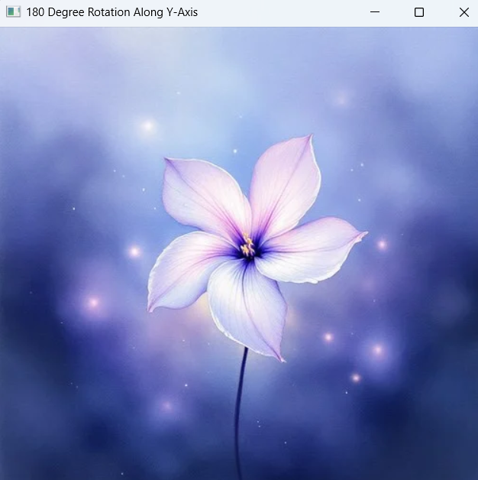
Output:

